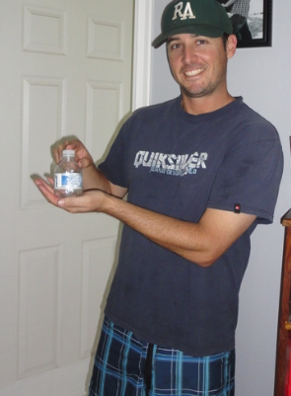
P
PINES SURFBOARD WAX

“My new surfboard wax will outlast the current wax in all weather conditions giving surfers a control and grip that they have never experienced”

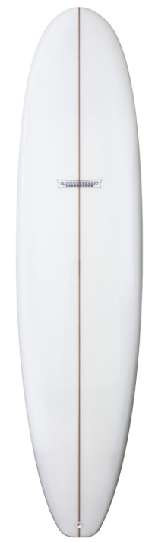
A block design will be used with each surfer receiving both types of wax on their surfboard. This is done to limit lurking variables such as skill level, type of surfboard, temperature of water, time of day, etc…
All surfer’s names in each block will be placed in a hat, half of the names will be randomly drawn to receive the New Wax on the Left side of their board and the other half will receive the New Wax on the Right side of their board
Matched Pairs with Blocking
RANDOMIZE
Volunteers(Surfers)
Goofy Foot
Regular Foot
New Wax Left Side of Board
Current Wax Right Side of Board
New Wax Right Side of Board
Current Wax Left Side of Board
New Wax Left Side of Board
Current Wax Right Side of Board
New Wax Right Side of Board
Current Wax Left Side of Board
Compare Results
New Wax
Current Wax

