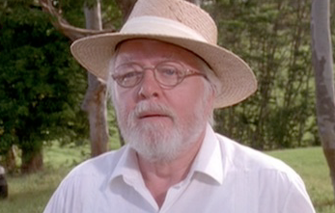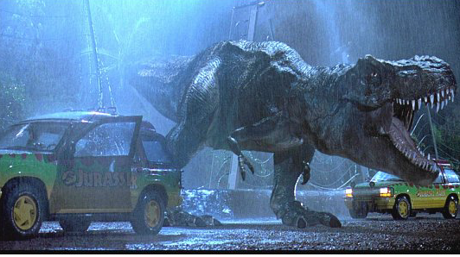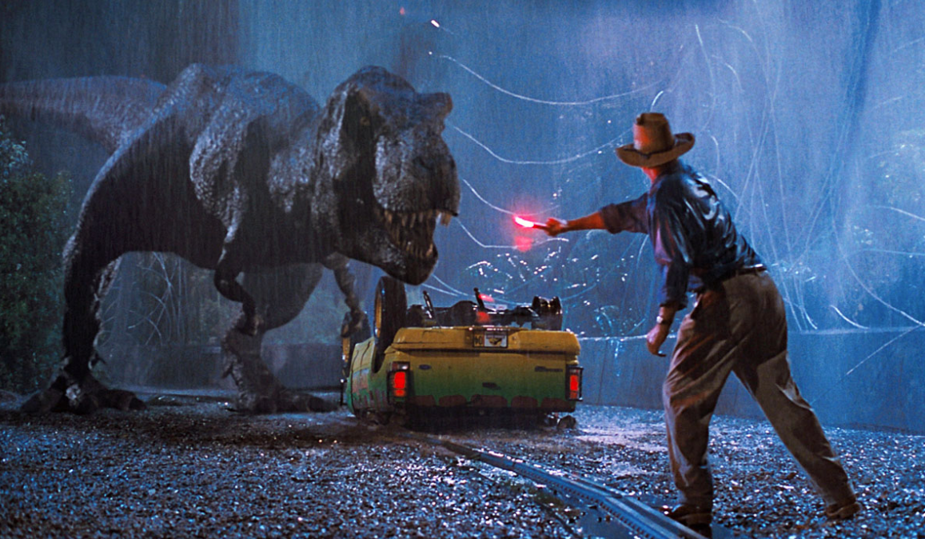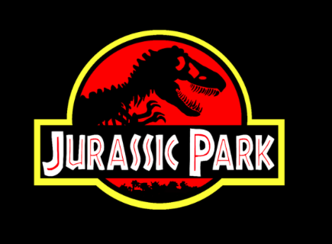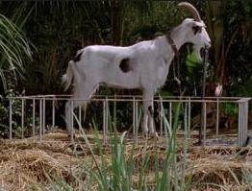

T-Rex doesn’t want to be fed, he wants to hunt!

We have a major problem

I suggest a Completely Randomized Design

**The T-Rex’s at Jurassic Park are getting out of their enclosures too often. The problem may be that they are bored and need to be challenged.**

The 50 T-Rex’s we have available for this experiment will be numbered 1-25, we will place those #’s in a hat. 25 numbers will be randomly drawn from the hat to be fed chained up goats, the remaining 25 T-Rex’s will hunt for their goats…we will compare escape attempts after 2 weeks.

Chained up Goat

Hunt for their Goat

Randomize